06hJuly 2016

**FIA ETCC heading to spectacular conclusion**

The European Touring Car Cup, which has the Japanese Tyre manufacturer YOKOHAMA as its Official Tyre supplier, heads off to Magny-Cours in France from 8th-10th July, in the second last racing weekend of the Championship.

With a very close contention at the top in the Super 2000 category, between the Swiss driver Kris Richard (74pts) who leads by only 2 points from the successful ETCC veteran Czech driver Peter Fulin (72pts ) everything is possible this weekend at Magny-Cours. With a combination of slow hairpins and high-speed chicane sections, it is very difficult to overtake at the French circuit so good starting positions at the grid are essential. The first-gear Adelaide hairpin probably offers the best overtaking opportunity on the circuit and will remain a focal part in the hopes and aspirations of the leaders in the race.

In the super 1600 category, Niklas Mackschin is a run away leader with a substantial 101pts and followed by Andreas Rinke on 62pts. If he manages good results Mackschin could put his second successive class title beyond the grasp of his immediate pursuers.

Meanwhile in the Ladies trophy with Ulrike Krafft not able to compete at Magny-Cours due to work commitments, the Ukrainian Ksenia Niks will be unchallenged in the battle for ETCC Ladies’ Cup points.

A spokesman for YOKOHAMA Europe expressed satisfaction at the way the season has evolved and the very good tyre performance in all the races, highlighting that the Championship is still very competitive even at such a late stage with only Magny-Cours and the final season closer at the historical circuit of Imola in Italy, from the 30th September – 2nd October. “We witnessed some fantastic driving at the Nordschleife and more recently at Vila-Real in Portugal, so we can be assured, there is still plenty of excitement to come in the last few races left, so good luck to all the drivers”, added David Oliva, Communications Manager for YOKOHAMA Europe.

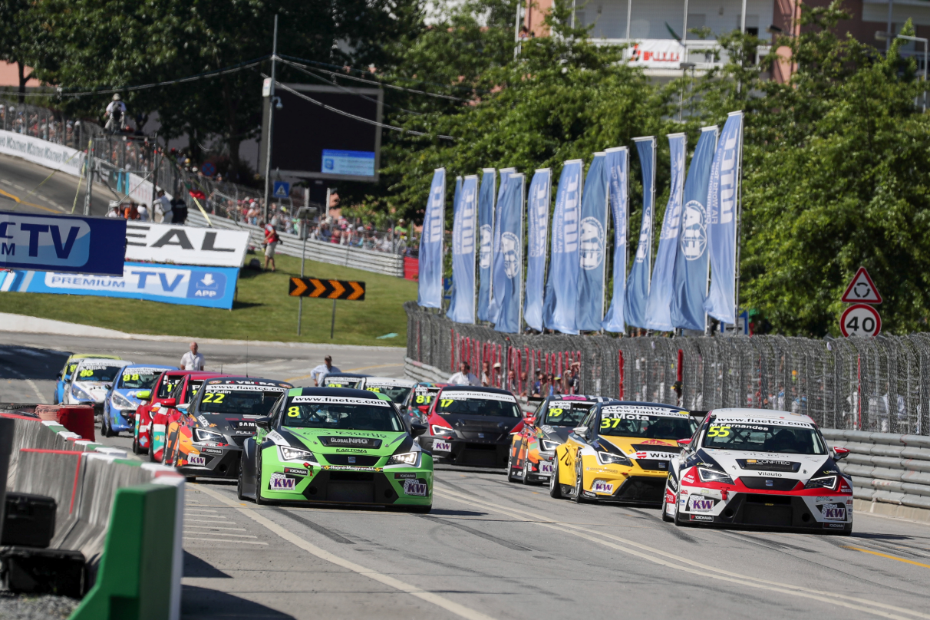

*Exciting competition at the ETCC Race of Portugal*

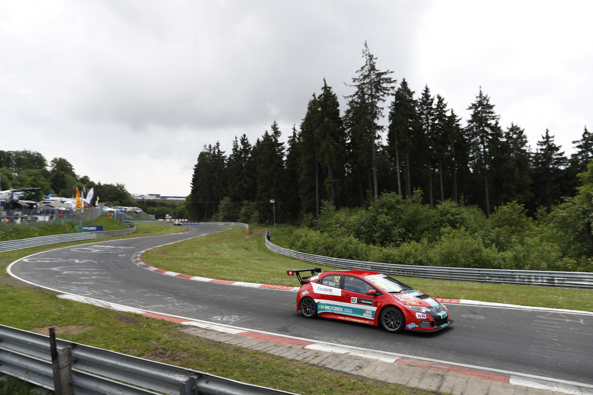

*FIA ETCC at the Nordschleife*

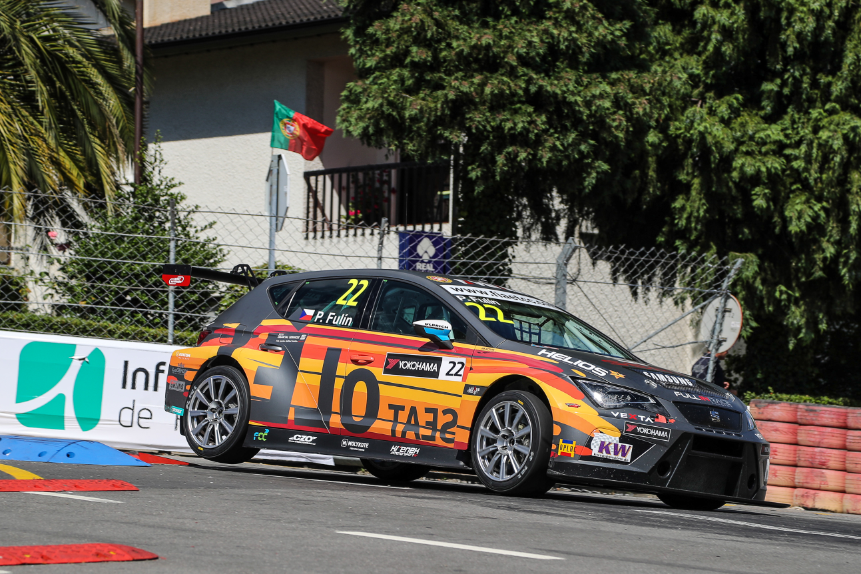

*FIA ETCC Race in Vila-Real Portugal*